**Using Matlab for First Order ODEs**

**Contents**

[Inline functions](http://www.wam.umd.edu/%7Epetersd/246/matlabode.html" \l "L584)

[Direction fields](http://www.wam.umd.edu/%7Epetersd/246/matlabode.html" \l "L585)

[Numerical solution of initial value problems](http://www.wam.umd.edu/%7Epetersd/246/matlabode.html" \l "L586)

[Plotting the solution](http://www.wam.umd.edu/%7Epetersd/246/matlabode.html" \l "L588)  
[Combining direction field and solution curves](http://www.wam.umd.edu/%7Epetersd/246/matlabode.html" \l "L589)  
[Finding numerical values at given t values](http://www.wam.umd.edu/%7Epetersd/246/matlabode.html" \l "L590)

[Symbolic solution of ODEs](http://www.wam.umd.edu/%7Epetersd/246/matlabode.html" \l "L591)

[Finding the general solution](http://www.wam.umd.edu/%7Epetersd/246/matlabode.html" \l "L592)  
[Solving initial value problems](http://www.wam.umd.edu/%7Epetersd/246/matlabode.html" \l "L593)  
[Plotting the solution](http://www.wam.umd.edu/%7Epetersd/246/matlabode.html" \l "L594)  
[Finding numerical values at given t values](http://www.wam.umd.edu/%7Epetersd/246/matlabode.html" \l "L595)

**Inline Functions**

If you want to use a function several times it is convenient to define it as a so-called *inline function*:

f1 = **inline(**'sin(x)*x','x')

defines the function f1(x)=sin(x)*x. Note that the arguments of inline must be *strings* (not symbolic expressions). You can then use the function f1 in expressions you type in.

You can also define inline functions of several variables:

g1 = inline('x*y+sin(x)','x','y')

defines the function g1(x,y)=x*y+sin(x) of two variables.

**Direction Fields**

**First download the file [dirfield.m](http://www.wam.umd.edu/%7Epetersd/246/dirfield.m)** and put it in the same directory as your other m-files for the homework.

**Define an inline function g** of two variables t, y corresponding to the right hand side of the differential equation *y*'(*t*) = *g*(*t*,*y*(*t*)). E.g., for the differential equation *y*'(*t*) = *t y*2 define

g = inline('t*y^2','t','y')

You have to use inline(...,**'t'**,**'y'**), even if t or y does not occur in your formula.

**To plot the direction field** for t going from t0 to t1 with a spacing of dt and y going from y0 to y1 with a spacing of dy use **dirfield(g,t0:dt:t1,y0:dy:y1)**. E.g., for t and y between -2 and 2 with a spacing of 0.2 type

**dirfield**(g,-2:0.2:2,-2:0.2:2)

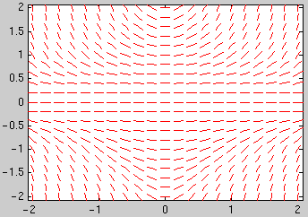

**Solving an initial value problem numerically**

**First define the inline function g** corresponding to the right hand side of the differential equation *y*'(*t*) = *g*(*t*,*y*(*t*)). E.g., for the differential equation *y*'(*t*) = *t y*2 define

g = inline('t*y^2','t','y')

**To plot the numerical solution of an initial value problem:** For the initial condition y(t0)=y0 you can plot the solution for t going from t0 to t1 using **ode45(g,[t0,t1],y0)**.

*Example:* To plot the solution of the initial value problem *y*'(*t*) = *t y*2, *y*(-2)=1 in the interval [-2,2] use

**ode45**(g,[-2,2],1)

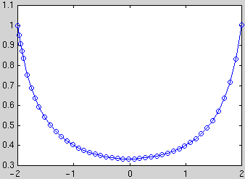

The circles mark the values which were actually computed (the points are chosen by Matlab to optimize accuracy and efficiency). You can obtain vectors ts and ys with the coordinates of these points using **[ts,ys] = ode45(g,[t0,t1],y0)**. You can then plot the solution using **plot(ts,ys)** (this is a way to obtain a plot without the circles).

**To combine plots of the direction field and several solution curves** use the commands **hold on** and **hold off**: After obtaining the first plot type hold on, then all subsequent commands plot in the same window. After the last plot command type hold off.

*Example:* Plot the direction field and the 13 solution curves with the initial conditions *y*(-2) = -0.4, -0.2, ..., 1.8, 2:

dirfield(g,-2:0.2:2,-2:0.2:2)

hold on

for y0=-0.4:0.2:2

[ts,ys] = ode45(g,[-2,2],y0); plot(ts,ys)

end

hold off

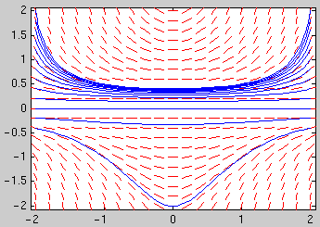

**To obtain numerical values of the solution at certain t values**: You can specify a vector tv of t values and use **[ts,ys] = ode45(g,tv,y0)**. The first element of the vector tv is the initial t value; the vector tv must have at least 3 elements. E.g., to obtain the solution with the initial condition *y*(-2)=1 at t = -2, -1.5, ..., 1.5, 2 and display the results as a table with two columns, use

[ts,ys]=ode45(g,-2:0.5:2,1);  
[ts,ys]

**Solving a differential equation symbolically**

You have to specify the differential equation in a *string*, using Dy for *y*'(*t*) and y for *y*(*t*): E.g., for the differential equation *y*'(*t*) = *t y*2 type

sol = **dsolve**('Dy=t*y^2','t')

The last argument 't' is the name of the independent variable. Do not type y(t) instead of y.

If Matlab can't find a solution it will return an empty symbol. If Matlab finds several solutions it returns a vector of solutions.

Sometimes Matlab can't find an explicit solution, but returns the *solution in* ***implicit form***. E.g., dsolve('Dy=1/(y-exp(y))','t') returns

t-1/2*y^2+exp(y)+C1=0

Unfortunately Matlab cannot handle initial conditions in this case. You can use **ezcontour**('t-1/2*y^2+exp(y)',[-4 4 -3 3]) to plot several solution curves for t in [-4,4], y in [-3,3]. You can use **ezplot**('t-1/2*y^2+exp(y)**-1**',[-4 4 -3 3]) to plot only the curve where t-1/2*y^2+exp(y)=1.

The solution will contain a constant C1. You can substitute values for the constant using **subs(sol,'C1',value)**. E.g., to set C1 to 5 and plot this solution for t=-2 to 2 use

ezplot( subs(sol,'C1',5) , [-2 2] )

**To solve an initial value problem** additionally specify an initial condition:

sol = dsolve('Dy=t*y^2','y(-2)=1','t')

**To plot the solution** use **ezplot(sol,[t0,t1])**. Here is an example for plotting the 13 solution curves with the initial conditions *y*(-2) = -0.4, -0.2, ..., 1.8, 2:

sol = dsolve('Dy=t*y^2','y(-2)=y0','t')

for y0=-0.4:0.2:2

ezplot( subs(sol,'y0',y0) , [-2 2])

hold on

end

hold off

axis tight

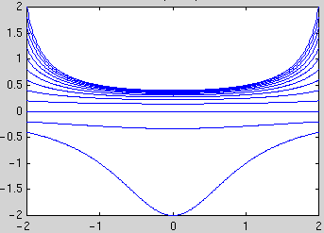

**To obtain numerical values** at one or more t values use **subs(sol,'t',tval)** and **double** (or **vpa** for more digits):

sol = dsolve('Dy=t*y^2','y(-2)=1','t')

This gives a numerical value of the solution at t=0.5:

double( subs(sol,'t',0.5) )

This computes numerical values of the solution at t=-2, -1.5, ..., 2 and displays the result as a table with two columns:

tval = (-2:0.5:2)'; % column vector with t-values  
yval = double( subs(sol,'t',tval) )% column vector with y-values  
[tval,yval] % display 2 columns together

(continued in [Using Matlab for Higher Order ODEs and Systems of ODEs](http://www.wam.umd.edu/%7Epetersd/246/matlabode2.html))

[MATH 246 course page](http://www.wam.umd.edu/%7Epetersd/246/Welcome.html)

[*Tobias von Petersdorff*](http://www.wam.umd.edu/%7Epetersd/Welcome.html)